Job Description-Caffi Assistant-Part Time-Dyfi Wildlife Centre

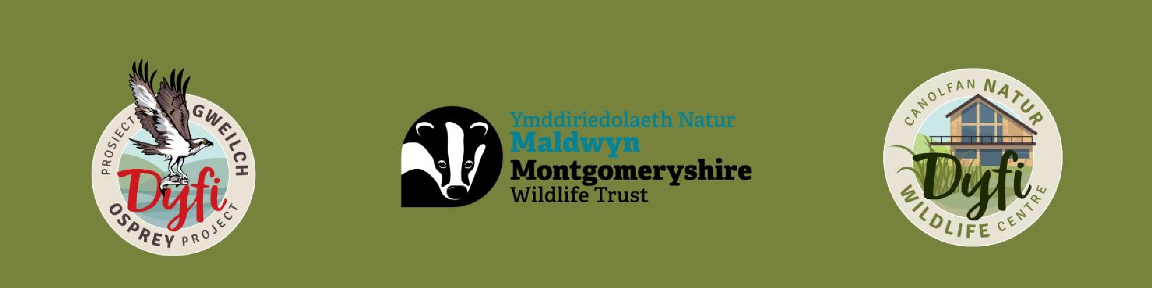

Job Title: Caffi Assistant

Salary: 21 hours a week- £23,000 Pro Rata

Contract Location: Dyfi Wildlife Centre, Cors Dyfi Reserve

Report To: Café Manager

# **Job Summary**

The Dyfi Wildlife Centre is a newly built Wildlife Centre on the beautiful Cors Dyfi Nature Reserve run by Montgomeryshire Wildlife Trust. The Dyfi Wildlife Centre is home to the popular Dyfi Osprey Project. We are passionate about providing an engaging and educational experience for our visitors, and upholding a sustainable approach to all that we do. The role will include being first point of contact for café visitors, taking and serving orders, preparing drinks and food as required and ensuring the café is clean and tidy. We are looking for friendly and enthusiastic people to join the team and help to deliver an excellent standard of refreshments for all visitors. Working times may vary depending on café demand but will include weekend, bank holiday and some possible evening working.

**Key Responsibilities**

* Take, fulfil and serve visitor orders.
* Maintaining the agreed standards of café cleanliness and presentation
* Ensuring café delivers timely, efficient and customer focussed service to all guests.
* Positively contribute to all visitor experiences
* Any other tasks as required

**Person Specification**

**Essential**

-Friendly with great Communication skills

-Team worker

-Motivated

-Reliable  
-Available to work Sundays  
  
**Desirable**-Previous hospitality or catering experience  
-Welsh Speaker  
  
Contact: Catering Manager- nadine@montwt.co.uk