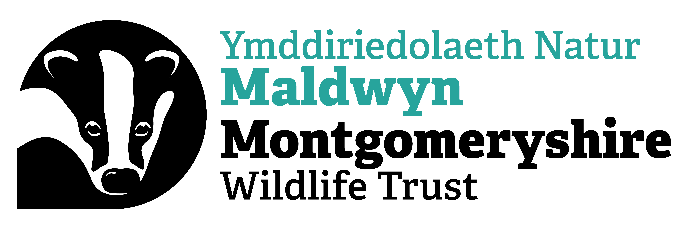

Montgomeryshire Wildlife Trust

Minutes of the Forty First Annual General Meeting

The Forty First Annual General Meeting of the Montgomeryshire Wildlife Trust was held on Tuesday 7th November 2023 at 7.00pm at Plas Dolerw, Newtown, Powys, SY16 2EH.

Chris Townsend (MWT President and AGM Chair) welcomed those present to the meeting. There were 31 members in attendance. Eight proxy votes were received prior to the 31st October 2023 deadline. Seven of these proxy votes gave their voting authority to the meeting Chair and one gave their voting authority to Katy Wright.

1) To receive and record any apologies for absence
Apologies were received from John Meredith-Jones, Eva Meredith-Jones, Sian Dorward, Gina Jones, Andy Hughes, Sue Hughes, Gillian Roberts, Robert Williams, Mair Braby, Michael Braby, Natalia McKensie, Glenys McKee, Andrew Stone and Paul Harris.

2) To consider the minutes of the Fortieth Annual General Meeting and to deal with any matters arising

Motion | Proposer | Seconder | For | Against | Abstentions
Adoption of the minutes of the 2022 AGM as a true record | Clare Boyes | Tim Ward | 36 | 0 | 3

There were no matters arising.

3) To elect members to the Trust’s Council

The following Trustees were seeking ratification

Trustee | Proposer | Seconder | For | Against | Abstentions
Susan Morley | Simon Boyes | Jill Robinson | 37 | 0 | 2
Nick Burton | Tim Ward | Sandy Scott | 37 | 0 | 2

Peter Powell retired by rotation after serving 2 terms (6 years) and was thanked by Chris Townsend for his years of service to the Trust.

4) To receive the report of the Trust’s Chairman
Tim McVey welcomed everyone to the 41st AGM of the Montgomeryshire Wildlife Trust. He referred those present to the Annual Review 22/23 and spoke of the wide range of projects the Trust has worked on this year, including:
- Working with young people combating climate change through the Stand For Nature Wales project.
- Offering opportunities to local people with mental and physical health issues through the Wild Skills, Wild Spaces project.
- Habitat management for key species, such as Curlew and the Pearl-bordered fritillary butterfly.
- Increased engagement with community groups and individuals through the Green Connections and Team Wilder projects.
- Developments at Cors Dyfi Naure Reserve, including the installation of solar panels and EV charging points on the car park, as well as the reintroduction of the boardwalk loop.
- The ongoing management of the Trust’s nature reserves, protecting the habitats and wildlife found there and increasing biodiversity.
TM commended the staff, volunteers and Trustees for their dedication to the work of the Trust, and also thanked the members for their continued support of the Trust’s mission.

5) To consider and approve the audited Financial Statements for the year ended 31st March 2023
Ann Bitcon (AB) referred those present to the summary Balance Sheet and SOFA included with the Annual Review 2022/23 and made the following observations:
- The full audited annual accounts will be available on the Trust website shortly.
- The accounts are the consolidated figures for Montgomeryshire Wildlife Trust Ltd and MWT Trading Ltd.
- The SOFA shows income for the year of £1,662,495 while overall expenditure was £1,054,586. This resulted in a surplus on the year of £607,909.
- AB reported that the figures marked Restricted include the Trust’s project income and expenditure which resolves to zero over time. The large surplus on this line is due to the grants received for Cors Dyfi which are released over time and the Peter Murdoch legacy. The Unrestricted values are mostly for Core income and costs and show a deficit on the accounts of £18,648. This is disappointing but was expected.
- The value of the assets on the Balance Sheet has increased this year due to capital works on the nature reserves.
- AB thanked Clive Faulkner for his ongoing determination to keep MWT financially sustainable. She also thanked Eley Hart and the staff team, her fellow Trustees on Finance Committee and Council and the team at Mitchell Charlesworth for their support during the audit.
- Chris Townsend acknowledged the enormous debt the Trust owes AB and proposed a vote of thanks for her work on the accounts which was echoed by all present.

Motion | Proposer | Seconder | For | Against | Abstentions
Adoption of the 2022/23 Annual Accounts | Ann Bitcon | Sarah Evans | 39 | 0 | 0

6) To receive the report of the auditors
Jamielee Johnston (Mitchell Charlesworth) thanked those present for the opportunity to speak at the AGM. JJ reported that the audit fieldwork had taken place in June and had included a visit to Cors Dyfi and the Dyfi Wildlife Centre. The audit process has gone smoothly and JJ thanked AB, EH and the Trust staff for their support. JJ concluded by confirming that MC has issued a clean, unqualified audit report for the Trust’s 2022/23 statutory accounts.

7) To appoint Auditors for the ensuing year
Tenders were sought and received to undertake the MWT audit. Mitchell Charlesworth was the successful candidate and have been appointed for 3 years.

8) Any other business
None

Chris Towsend announced that he was standing down as MWT President and said it had been an honour to be involved with the work of the Trust for so many years. He praised the achievements of MWT, despite the organisation’s relatively small size, and thanked the staff and volunteers who go above and beyond to protect the wildlife of Montgomeryshire.

Tim McVey then presented CT with a painting by renowned local artist Terence Lambert, depicting a pair of Herons at Llyn Coed y Dinas nature reserve, where CT is warden. TM thanked CT for his support over the years and his commitment to the work and mission of the Trust, praising his dedication to ornithology and wildlife conservation.

The meeting closed at 7.40pm.

There followed a presentation by Adrian Jones (North Wales Wildlife Trust) on the Welsh Beaver Project.

ENDS

