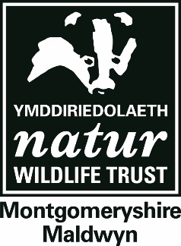
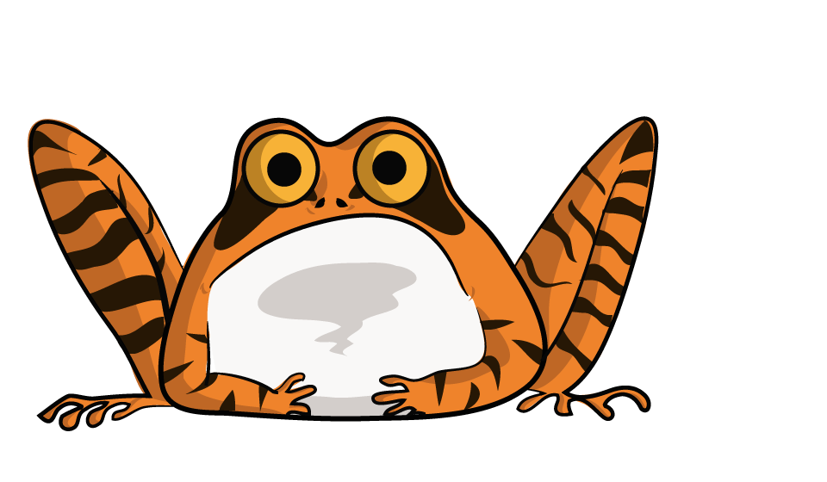
OUTDOOR LEARNING
Key Stage 3
Our Key Stage 3 programmes train children to start thinking like Biologists, Ecologists, Zoologists and Botanists, testing their abilities to ask deeper questions about life on Earth and equip them with their first field scientist skills.
Our education programme can either be delivered at five of our 18 nature reserves or brought to other sites, be they schools or other personal grounds. Sessions are led by experienced staff who are first aid trained and DBS checked to give you peace of mind and your class a unique immersive experience. A day typically runs from 10:00-14:15, including a break for your packed lunch.
Physical development
Communication & language
Understanding the world

Expressive arts & design
Personal, social & emotional development
Literacy
Maths

Bushcraft
Pond-dipping

Children will test their survival skills by learning to make a fire or building a shelter in the woodland, among other woodwork skills. As part of the session, they’ll make a Boghart (tree spirit) out of clay, learn about native plants and animals and play woodland games!
The children will hunt in small groups, collecting pond creatures and recording what they find. We will then study them in more depth with our ‘show and tell’ sessions.

Mini-beast Hunting
Survey Skills
The children will hunt in small groups, collecting mini-beasts with a range of methods (including beat-sheets and sweep-nets), recording what they find. We will then study them in more depth with our ‘show and tell’ sessions.
Children will learn to walk transects for surveys, take square quadrats and calculate percentage cover of plant species. This may be extended to include woodland survey techniques, such as measuring percentage of canopy cover or different recording tree ages, or presence of non-native species. For those up to the challenge, we’ll aim to identify 10 common bird songs.

Creatures of the Night Workshop

This workshop will look at which creatures inhabit the habitats at night. The children will learn about tracks and signs left by nocturnal animals. This will lead to barn owl pellet dissection. The children will make a bat hat or a clay hedgehog to take home.

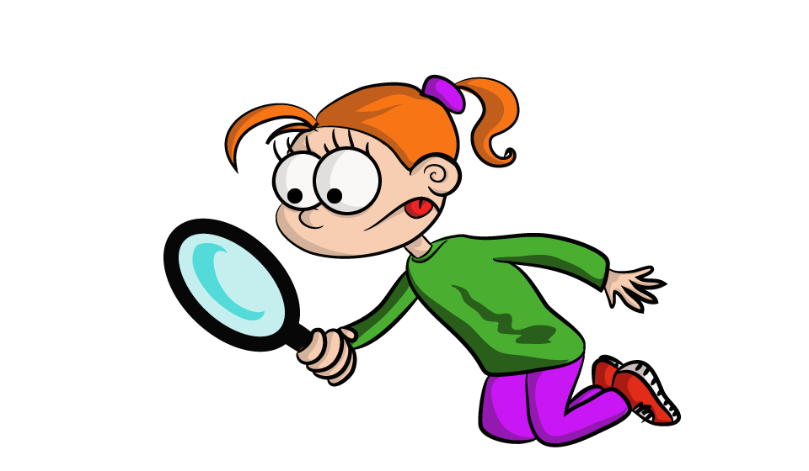
Homes For Nature
Children will learn how to create food webs and food chains, and their place within them. They’ll learn about the evolution of birds, and how this process affects all life. In particular, the role extinction has to play on life on Earth, and how we as humans are influencing it.
A Session of Life and Death
This session looks to involve parents and children and members of the community to improving a local area for wildlife. Depending on the space in question, we provide materials and expertise to create ponds, bug hotels or bird boxes in dedicated training workshops. Duration and cost of this session vary between the kind of habitat being created and the size of the area used.

