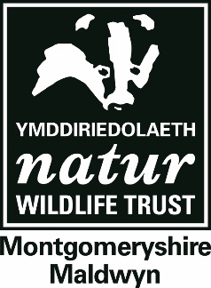

**Key Stage 2**

**OUTDOOR LEARNING**

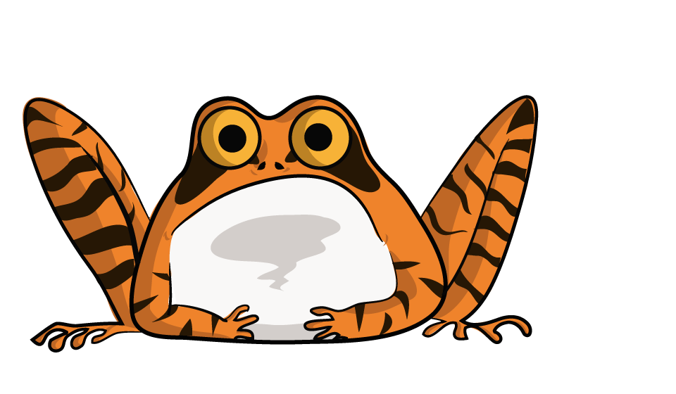

**Our Key Stage 2 programmes help children take their next steps into the wonderful world of wildlife through activities designed to inspire creativity, teamwork and interaction with nature.**

Our education programme can either be delivered at five of our 18 nature reserves or brought to other sites, be they schools or other personal grounds. Sessions are led by experienced staff who are first aid trained and DBS checked to give you peace of mind and your class a unique immersive experience. A day typically runs from 10:00-14:15, including a break for your packed lunch.



**Physical development**

**Communication & language**



**Understanding the world**



**Expressive arts & design**

**Personal, social & emotional development**

**Literacy**

**Maths**



**Bushcraft**

**Natural Art**

Children will create varied pieces of art using natural materials and the wonderful colours abundant in nature.



Children will test their survival skills by learning to make a fire or building a shelter in the woodland, among other woodwork skills. As part of the session, they’ll make a Boghart (tree spirit) out of clay, learn about native plants and animals and play woodland games!



**Survey Skills**

**Pond-dipping**



Children will learn to walk transects for surveys, take square quadrats and calculate percentage cover of plant species. This may be extended to include woodland survey techniques, such as measuring percentage of canopy cover or different recording tree ages, or presence of non-native species. For those up to the challenge, we’ll aim to identify 10 common bird songs.

**Mini-beast Hunting**



The children will hunt in small groups, collecting pond creatures and recording what they find. We will then study them in more depth with our ‘show and tell’ sessions.



**Creatures of the Night Workshop**

The children will hunt in small groups, collecting mini-beasts with a range of methods (including beat-sheets and sweep-nets), recording what they find. We will then study them in more depth with our ‘show and tell’ sessions.

This workshop will look at which creatures inhabit the habitats at night. The children will learn about tracks and signs left by nocturnal animals. This will lead to barn owl pellet dissection. The children will make a bat hat or a clay hedgehog to take home.

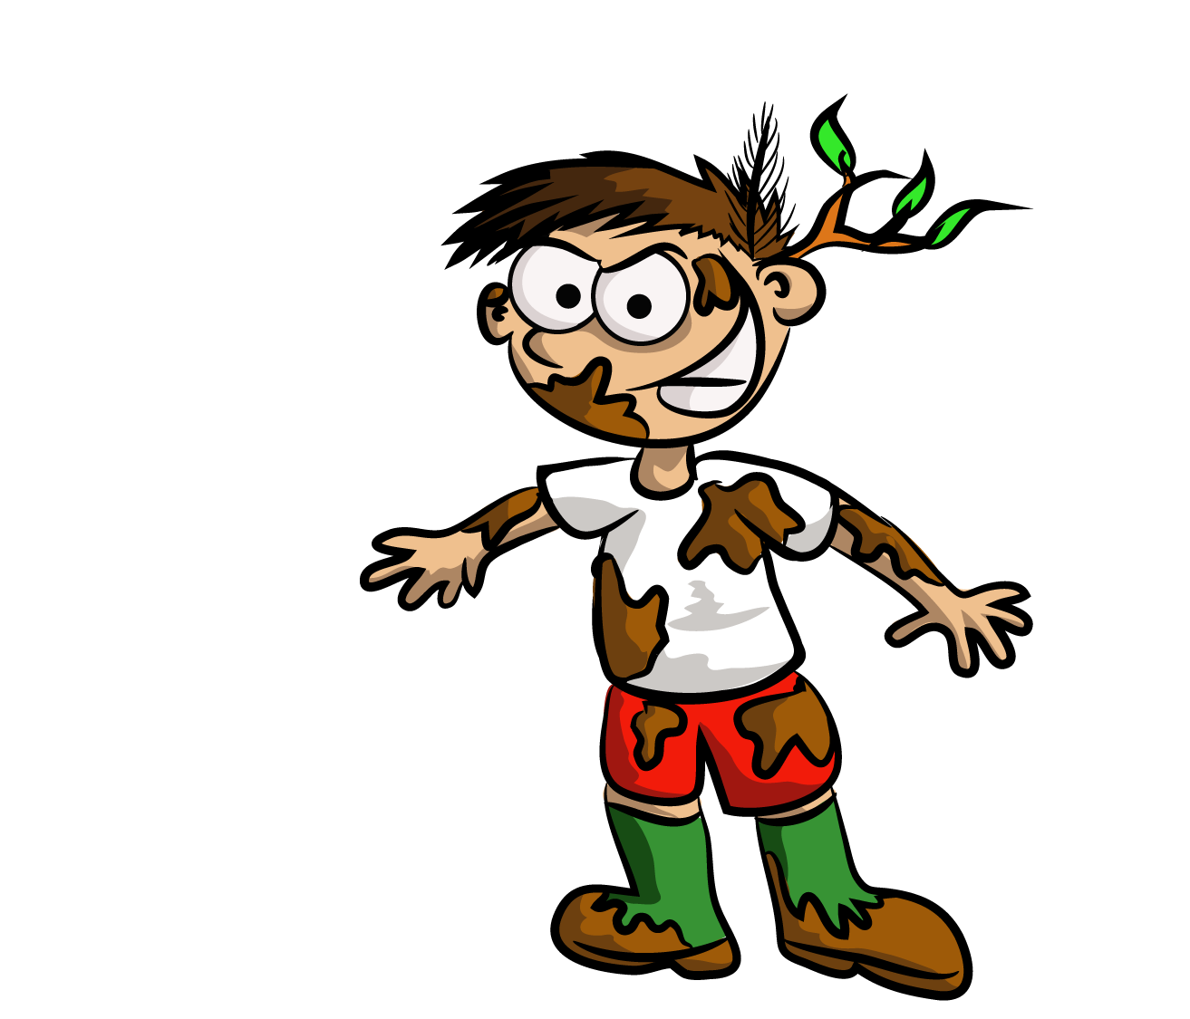

This session aims to get kids out and their hands in the dirt! Children will get to plant their own meadow or tree seeds, or plant out baby trees from our nature reserves, to grow either at school, a local wildlife site, at home or anywhere they want to create habitat for wildlife!



**Green Thumbs**

Children will learn how to create food webs and food chains, and their place within them. They’ll learn about the evolution of birds, and how this process affects all life. In particular, the role extinction has to play on life on Earth, and how we as humans are influencing it.



**A Session of Life and Death**

Children will learn how to become experts at settling petty arguments about wildlife…is it a duck or a goose? When is a bug *really* a bug? Learn about the things that set groups of animals apart, and what makes them similar by working together to build a tree of life, learn what features set birds apart and have a go at being one yourself…try your hand at ‘Beetle’, and even design your own insect!



**Fantastic Beasts and how to tell them apart**

**Homes For Nature**

This session looks to involve parents and children and members of the community to improving a local area for wildlife. Depending on the space in question, we provide materials and expertise to create ponds, bug hotels or bird boxes in dedicated training workshops. Duration and cost of this session vary between the kind of habitat being created and the size of the area used.

